Peter Sanford

IT 2700  
NetLab Lab 22  
11/04/2023

1.1

Step 7:

Step 10:

Step 13:

1.2

Step 4:

1.3

Step 9:

2.1

Step 16:

3.1

Step 1:

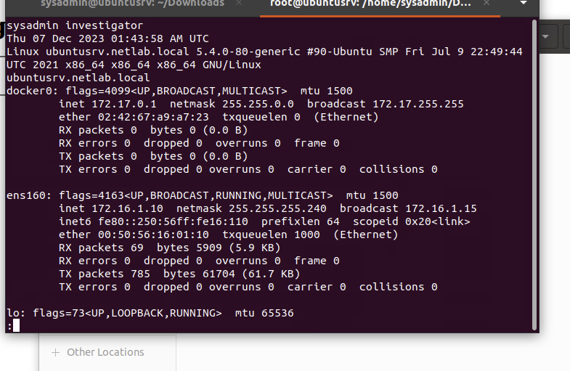

Step 4:

Commentary:

In this lab we viewed out linux logs after a compromise to see what clues there are to infiltrators. I learned what the logs look like when there’s an infiltrator and someone logged into your account that you don’t expect. Knowing this information, companies can go through their log files regularly and make sure there isn’t any unexpected entries.